|  |  |
| --- | --- |
| COLLEGE NAME | SARANATHAN COLLEGE OF ENGINEERING |
| TITLE | HOW TO CREATE BRAND NAME, BRAND MAIL AND BRAND LOGO IN CANVA |
| NAME | S.S.SRI ISWARYA |
| NM ID | 6B636CE9B8E743C804C4E1830AA17076 |
| DATE | 27-10-2023 |

BRAND NAME: COOLERSHADES

Linked In:

<https://www.linkedin.com/in/iswarya-senthilkumar-30b110269>

FACEBOOK :

<https://www.facebook.com/profile.php?id=61552679826772>

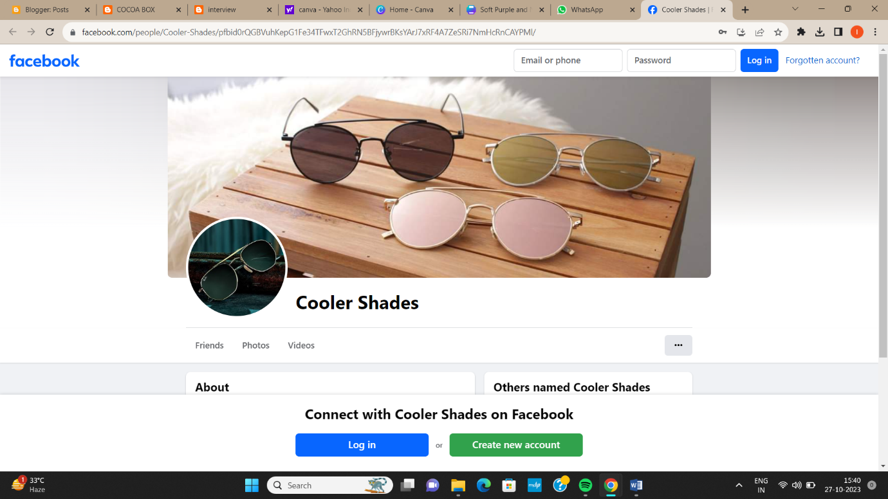

BLOG OR WEBSITE URL:

<http://electronicbeautyproducts.blogspot.com/2023/08/beauty-products-easy-breezy-beautiful.html>

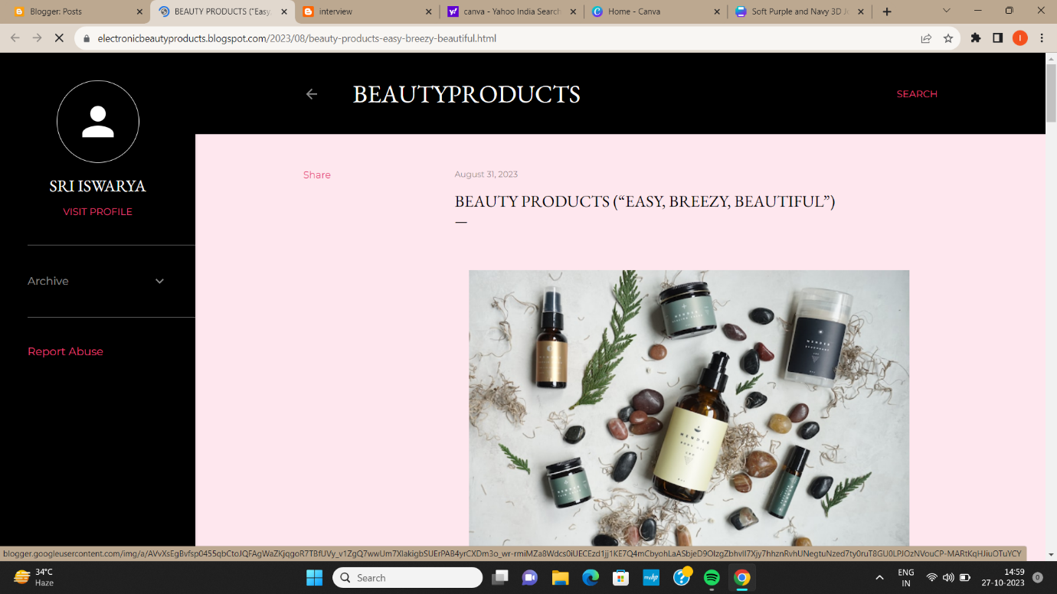

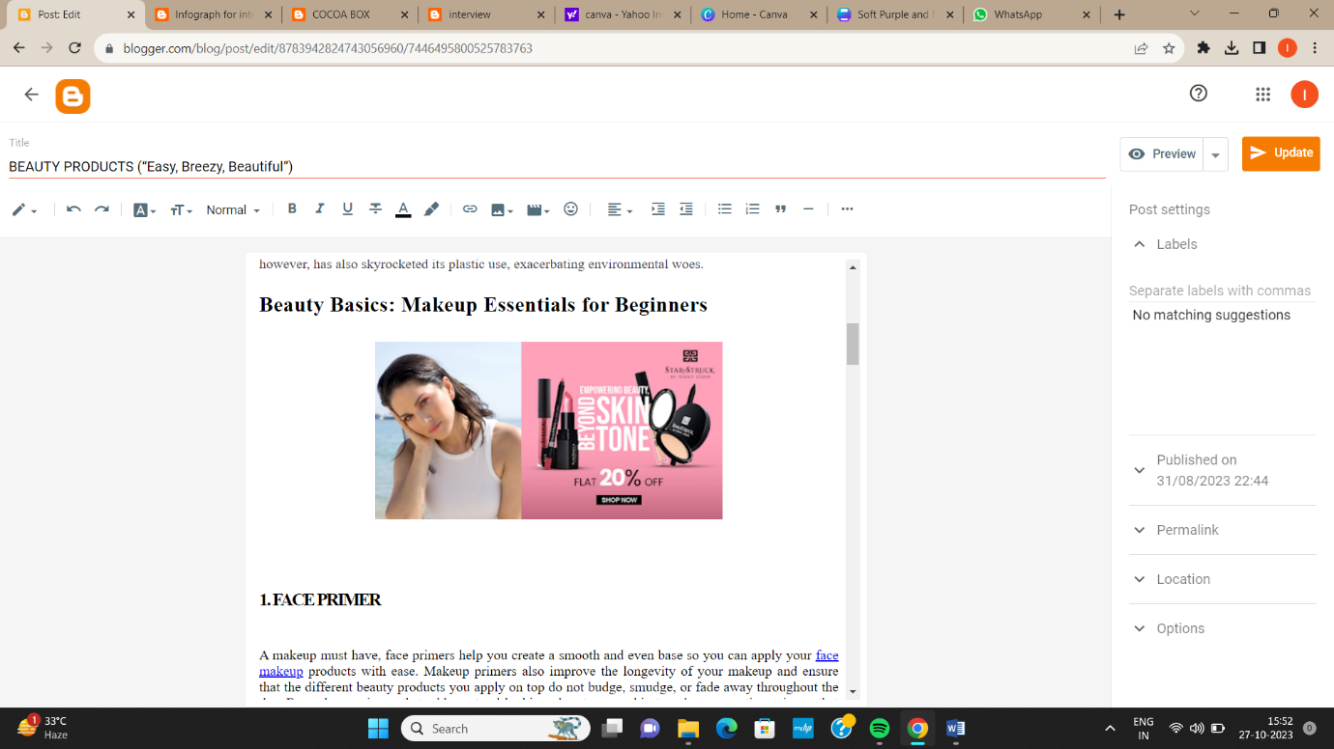

EMAIL NEWSLETTER:

<https://cocoaboxx.blogspot.com/2023/09/cocoa-box.html>

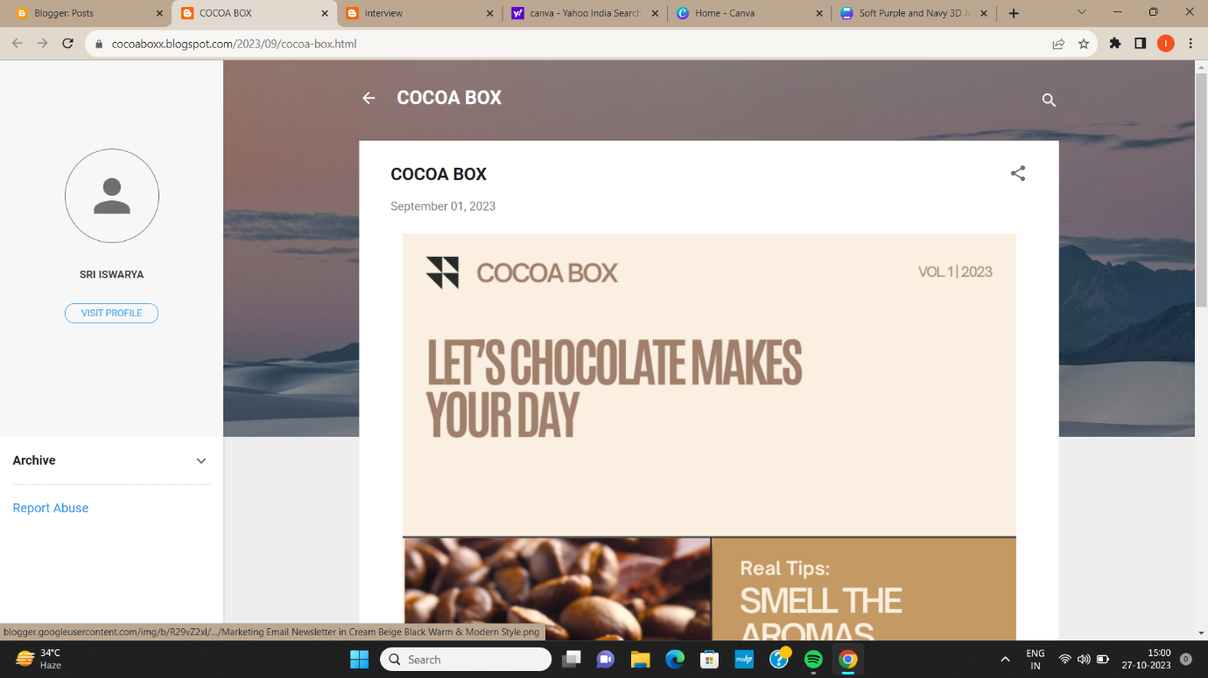

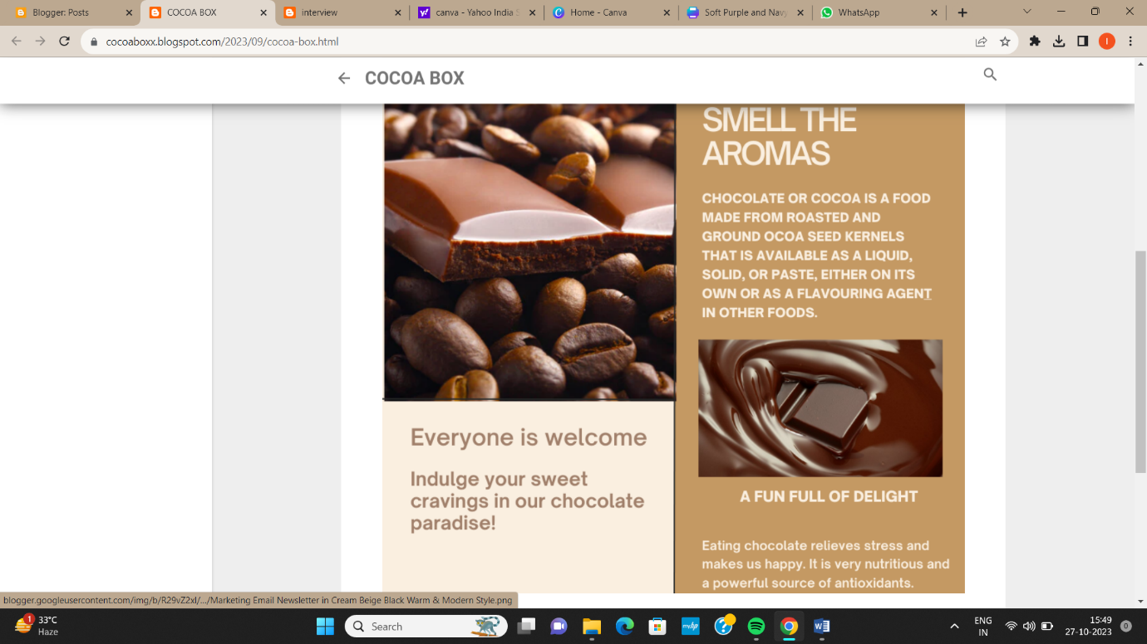

INFOGRAPHIC:

<https://interviewinfograph.blogspot.com/2023/09/infograph-for-interview.html>

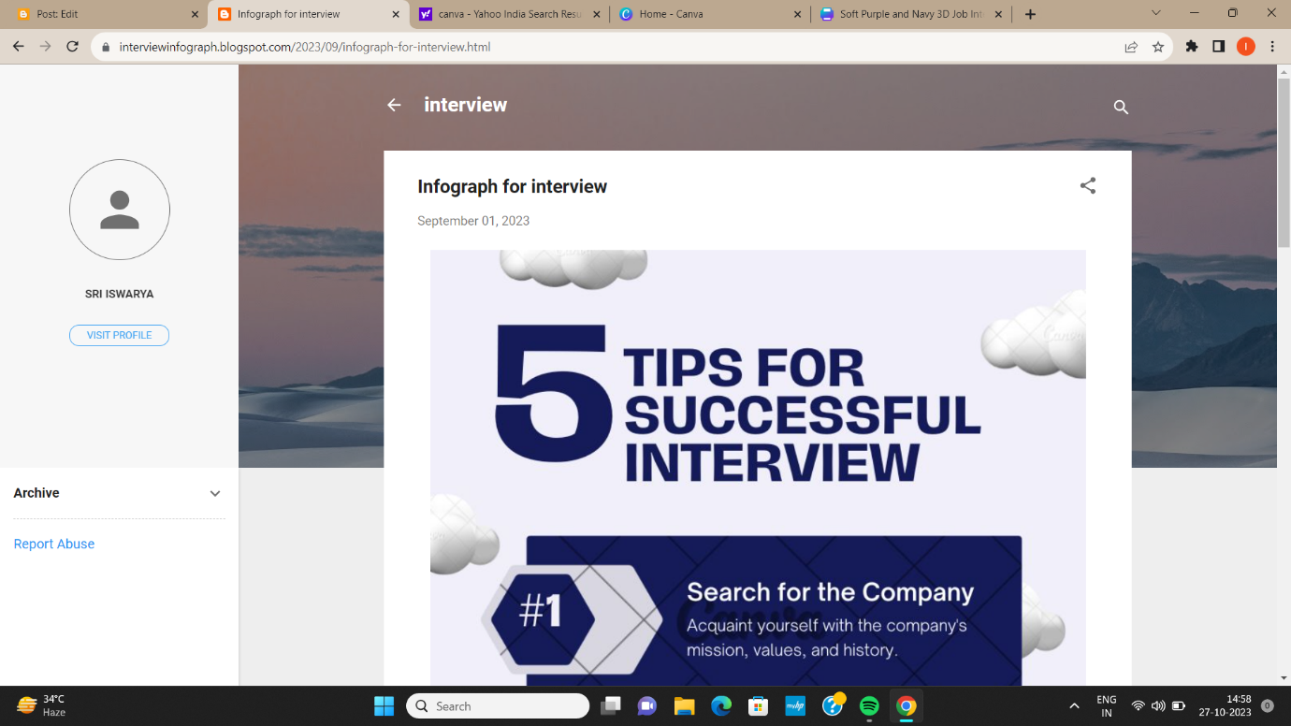

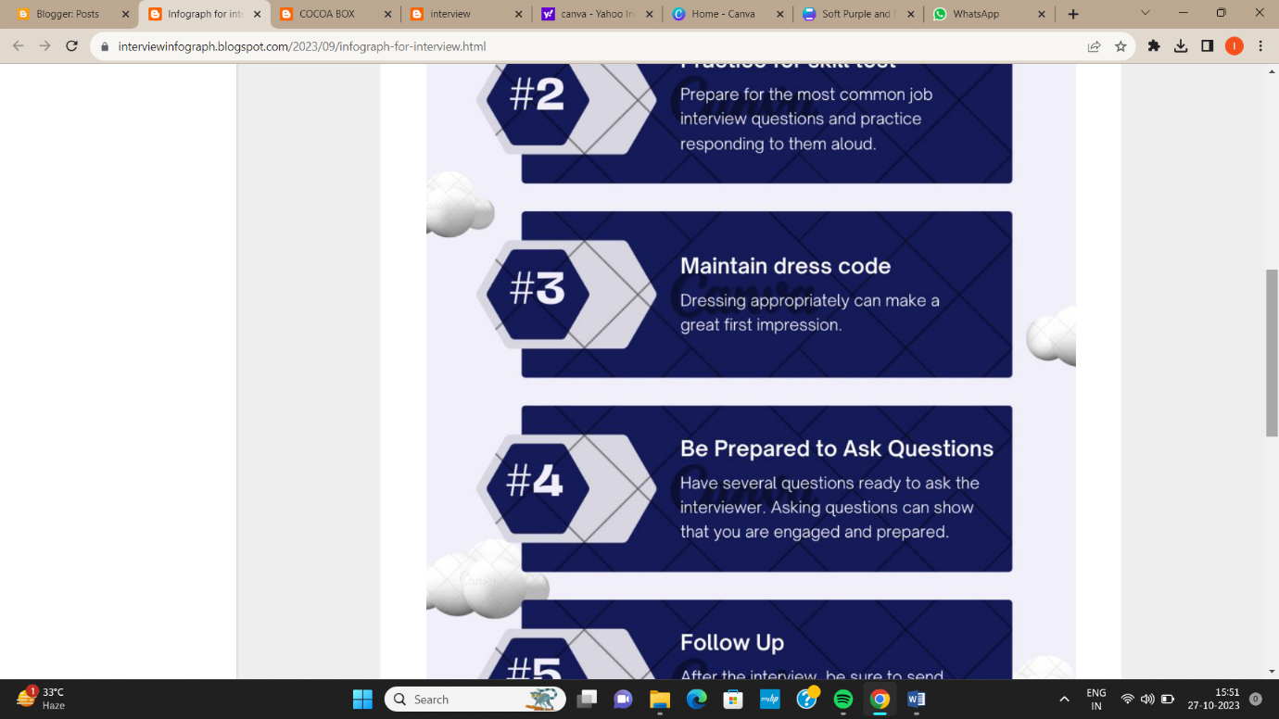

DEMO VIDEO LINK:

<https://drive.google.com/file/d/1F8Scm-TSYJf63EOnzMmiTZXPjt8p_KBK/view?usp=drivesdk>